Members: Daniil Blagoev, Jakub Jelínek, Rositsa nikolova, Rens van den Elzen

2/16/2022

URS Document



Tutor: Michiel Koehorst

Location: Eindhoven

Contents

Agreement with client 1

Functional requirements 1

App 1

Use cases 2

Wireframes 5

Administrator 5

Manager 7

Worker 8

## Agreement with client

We are going to deliver intermediate version of the system in week 6. We agreed for the first six weeks to focus on the employee management part of the application because this is the main priority for the company. We are also going to show the URS document and double check if all requirements are met also if there are any changes to be done before the implementation. During the process, in week 5 we are going to schedule a short meeting to show what we have done so far and if the client is happy with the user interface and functionalities. In week 6 we are adding the final touch and presenting the intermediate version.

For the second release of the system, we are going to focus on companies' second priority – managing stock. For this goal we will implement full functionalities for managing products. The next important step is making possible sending requests for products from the sales to the warehouse department. The requests can be fully approved, partially approved or rejected. We are also going to create a website where only 'workers' can login and see their own schedule. In week 9 we are going the present the software solution.

## Functional requirements

### App

**Admin**

* AFR-01: Admins should be able to create an employee
* AFR-02: Admins should be able to deactivate an employee
  + By deactivating an employee due to an employee terminating their contract for any reason, the employee’s data is not removed from the database, but employee cannot log in into the system
* AFR-03: Admins should be able to delete an employee
  + Employee will be deleted 2 years after their deactivation and the employee’s data will be removed from the database
* AFR-04: Admins should be able to update an employee's information
* The email, password, contract type, wage and position are updatable
* AFR-05: Admins should be able to see statistics
  + The statistics about employees and stock management
  + Statistics:
    - Employees: average salary, number of employees, employee nationalities, contract types
  + Stock management: number of all products, how many requests for re-shelf accepted and rejected, see all types of products
* AFR-06: Admins should be able to see all the shift schedules
* AFR-07: Admins should be able to assign an employee to a shift
* AFR-08: Admins should be able to remove employees from a shift
* AFR-09: Admins should be able to see an overview of all employees
* AFR-10: Admin should be able to search for an employee
* AFR-11: Admin should be able to log in
* AFR-12: Admin should be able to see list of all products
* AFR-13: Admin should be able to manage products in warehouse
  + Add, Edit and Remove any product

**Manager**

* MFR-01: Managers should be able to see all statistics
  + Same statistics as admin
* MFR-02: Managers should be able to see all the shift schedules
* MFR-03: Managers should be able to see an overview of all employees
* MFR-04: Manager should be able to search for an employee
* MFR-05: Manager should be able to log in
* MFR-06: Manager should see list of all products

**Employee**

* EFR-01: Employees should be able to see their own shift schedule
* EFR-02: Employee should be able to log in
* EFRW-03: Employee Warehouse
  + EFRW-W01: Should see all requests from Sales Employee
    - Has three weeks to finish the request
  + EFRW-W02: Should be able to **Accept** request
    - When amount of requested products is lower than amount in Warehouse
  + EFRW-W03: Should be able to **Partially Accept** request
    - When amount of requested products is higher than amount of products in Warehouse
  + EFRW-W04: Should be able to **Reject** request
    - When amount of requested products in Warehouse is 0
* EFRS-03: Employee Sales
  + EFRS-S01: Should be able to send re-shelf request to Warehouse Employee
    - Max. number of requested products is 10
  + EFRS-S02: Should be able to see status(Accepted, Partially Accepted, Rejected) of product request
  + EFRS-S03: Should see list of all products in the shop

### Website

**Admin**

**Manager**

**Employee**

* WEFR-01: Employee should be able to log in
* WEFR-02: Employee should be able to see their own shift schedule

## Use cases

Use case diagram

**UC-01 – AFR-01:**

**Use case: Create an employee**

**Actor: Admin**

**Main Success Scenario:**

1. Admin goes to create a new employee
2. System requests for the required fields to be filled in
3. Admin fills in the information fields and confirms
4. System confirms the employee has been added successfully

**Extensions:**

3a: There are empty information fields

.1: System displays an empty information field error message

.2: Return to MSS step 2

4a: The employee already exists

.1: System displays an error message stating that an employee with such information already exists

.2: Return to MSS step 2

3b: Some of the filled information is not valid

.1: System displays an error message stating that some of the filled information is not valid

.2: Return to MSS step 2

**UC-02 – AFR-02:**

**Use case: Deactivate an employee**

**Actor: Admin**

**Main Success Scenario:**

1. Admin goes to the list of employees
2. System shows the list of employees
3. Admin selects an employee and confirms
4. System marks the employee as inactive, and they can no longer login into the system

**Extensions:**

3a: An employee is not selected

.1: System displays an error message stating an employee was not selected

.2: Return to MSS step 2

**UC-03 – AFR-03:**

**Use case: Delete employee**

**Actor: Admin**

**Main Success Scenario:**

1. Admin goes to see the list employees
2. System shows the list of employees
3. Admin selects an employee to be delete
4. System deletes the selected employee and removes their data from the database

**Extensions:**

3a: An employee is not selected

.1: System displays an error message stating an employee was not selected

.2: Return to MSS step 2

**UC-04 – AFR-07:**

**Use case: Assign a worker to a shift**

**Actor: Admin**

**Main Success Scenario:**

1. Admin goes to assign a worker to a shift
2. System requests a day to be selected
3. Admin selects a day
4. System requests the morning, mid-day or evening shift to be selected
5. Admin selects one of the three shifts
6. System requests the user to select a worker to be assigned to the selected shift
7. Admin selects the worker they want
8. System confirms the worker has successfully been assigned to the shift

**Extensions:**

5a: A shift is not selected

.1: System displays an error message

.2: Return to MSS step 4

7a: A worker is not selected

.1: System displays an error message

.2: Return to MSS step 6

8a: The worker already has 2 shifts for the day

.1: System displays an error message

.2: Return to MSS step 6

5b: There are 10 workers assigned to the selected shift

.1: System displays an error message

.2: Return to MSS step 4

**UC-05 – AFR-08:**

**Use case: Remove a worker from a shift**

**Actor: Admin**

**Main Success Scenario:**

1. Admin goes to remove a worker from a shift
2. System requests a day to be selected
3. Admin selects a day
4. System requests a shift to be selected
5. Admin selects a shift
6. System shows the assigned workers in the selected shift
7. Admin selects a worker
8. System removes the selected worker from the shift

**Extensions:**

5a: A shift is not selected

.1: System displays an error message

.2: Return to MSS step 4

7a: A worker is not selected

.1: System displays an error message

.2: Return to MSS step 6

**UC-06 – AFR-04:**

**Use case: Update information for employee**

**Actor: Admin**

**Main Success Scenario:**

1. Admin goes to update information about employee
2. System shows the fields that can be edited
3. Admin edits the information about employee
4. System confirms the employee's information has been updated successfully

**Extensions:**

3a: There are empty information fields

.1: System displays an empty information field error message

.2: Return to MSS step 2

3b: Some of the filled information is not valid

.1: System displays an error message stating that some of the filled information is not valid

.2: Return to MSS step 2

**UC-07 – AFR-05/MFR-01:**

**Use case: View statistics of the shop**

**Actor: Admin/Manager**

**Main Success Scenario:**

1. Admin/Manager goes to see the statistics
2. System shows the statistics

**UC-08 – AFR-06/MFR-02:**

**Use case: Displaying schedule**

**Actor: Admin/Manager**

**Main Success Scenario:**

1. Admin/Manager goes to see the schedule
2. System shows the schedule for all employees

**UC-09 – AFR-09/MFR-03:**

**Use case: Displaying an overview of all employees**

**Actor: Admin/Manager**

**Main Success Scenario:**

1. Admin/Manager goes to see an overview of all employees
2. System shows the overview

**UC-10 – AFR-10/MFR-04:**

**Use case: Searching for employee by name**

**Actor: Admin/Manager**

**Main Success Scenario:**

1. Admin/Manager enters an employee’s name in the search bar
2. System displays information about employee(s) with a matching name

**Extensions:**

1a: Employee is not found

.1: System displays a massage stating there is no such employee

.2: Return to MSS step 1

**UC-11 – EFR-01:**

**Use case: Displaying schedule for worker**

**Actor: Worker**

**Main Success Scenario:**

1. Employee goes to see their schedule
2. System shows their own schedule

**UC-11 – EFR-02/MFR-05/AFR-11:**

**Use case: Logging into the app**

**Actor: Worker, Manager, Admin**

**Main Success Scenario:**

1. Actor opens the app
2. System shows the log in screen
3. Actor enters their credentials
4. System shows the view according to the entered credentials

**Extensions:**

3a: Invalid credentials

.1: System displays a message stating there is no such account

.2: Return to MSS step 3

3b: Empty credentials field

.1: System displays a message stating there is an empty field

.2: Return to MSS step 3

**UC-12 –AFR-12/MFR-06:**

**Use case: Product overview**

**Actor: Manager, Admin**

**Main Success Scenario:**

1. Admin/manager goes to see the list of all products in the store/warehouse
2. System shows the list of all products in the store

**UC-13 –AFR-13:**

**Use case: Adding a new product**

**Actor: Admin**

**Main Success Scenario:**

1. Admin goes to add a new product
2. System requests for the required fields to be filled in
3. Admin fills in the information fields and confirms
4. System confirms the product has been added successfully

**Extensions:**

3a: There are empty information fields

.1: System displays an empty information field error message

.2: Return to MSS step 2

4a: The product already exists

.1: System displays an error message stating that a product with such information already exists

.2: Return to MSS step 2

3b: Some of the filled information is not valid

.1: System displays an error message stating that some of the filled information is not valid

.2: Return to MSS step 2

**UC-14 – AFR-13:**

**Use case: Remove product**

**Actor: Admin**

**Main Success Scenario:**

1. Admin goes to see the list of products
2. System shows the list of products
3. Admin selects a product to be removed
4. System removes the selected product

**Extensions:**

3a: A product is not selected

.1: System displays an error message stating a product was not selected

.2: Return to MSS step 2

**UC-15 – AFR-13:**

**Use case: Update information for product**

**Actor: Admin**

**Main Success Scenario:**

1. Admin goes to update information about product
2. System shows the editable fields with product information
3. Admin edits the information about the product
4. System confirms the product’s information has been updated successfully

**Extensions:**

3a: There are empty information fields

.1: System displays an empty information field error message

.2: Return to MSS step 2

3b: Some of the filled information is not valid

.1: System displays an error message stating that some of the filled information is not valid

.2: Return to MSS step 2

**UC-16 – EFRW-W01:**

**Use case: Checking product requests**

**Actor: Warehouse employee**

**Main Success Scenario:**

1. The warehouse employee goes to see the product requests from the sales employees
2. System shows the product requests

**UC-17 – EFRW-W02/EFRW-W03:**

**Use case: Accepting a product request**

**Actor: Warehouse employee**

**Main Success Scenario:**

1. The warehouse employee goes to see the product requests from the sales employees
2. System shows the product requests from the sales employees
3. The warehouse employee selects a request and accepts it
4. The system shows confirmation the request was accepted successfully

**Extensions:**

3a: No product request selected

.1: System displays an error message stating a request wasn’t selected

.2: Return to MSS step 2

3b: Not enough products in the warehouse to fully accept request

.1: System displays an error message stating that the request cannot be fully accepted

.2: System partially accepts the request and displays a message stating the request has been partially accepted

3c: No stock in the warehouse for the request

.1: System displays an error message stating that the request cannot be accepted due to having no stock left in the warehouse

.2: Return to MSS step 2

**UC-18 – EFRW-W04:**

**Use case: Rejecting a product request**

**Actor: Warehouse employee**

**Main Success Scenario:**

1. The warehouse employee goes to see the product requests from the sales employees
2. System shows the product requests from the sales employees
3. The warehouse employee selects a request and rejects it
4. System shows confirmation the request was declined successfully

**Extensions:**

3a: No product request selected

.1: System displays an error message stating a request wasn’t selected

.2: Return to MSS step 2

**UC-19 – EFRS-S01:**

**Use case: Making a re-shelf request**

**Actor: Sales employee**

**Main Success Scenario:**

1. The sales employee goes to see the list of products
2. System shows the list of products
3. The sales employee selects a product from the list
4. The sales employee types the amount needed and confirms
5. System shows confirmation the request was made successfully

**Extensions:**

3a: No product selected

.1: System displays an error message stating a product wasn’t selected

.2: Return to MSS step 2

4a: Requesting more than 10 of a product

.1: System displays an error message stating that you cannot request more than 10 of a product per request.

.2: Return to MSS step 2

**UC-20 – EFRS-S02:**

**Use case: Checking request status**

**Actor: Sales employee**

**Main Success Scenario:**

1. The sales employee goes to see the status of requests
2. System shows a list of requests and their status

**UC-21 – EFRS-S03:**

**Use case: Checking all products in the store**

**Actor: Sales employee**

**Main Success Scenario:**

1. The sales employee goes to see the list of products in the store
2. System shows a list of products in the store

**UC-22 – WFR-01:**

**Use case: Logging into the website**

**Actor: Workers**

**Main Success Scenario:**

1. Worker opens the website
2. System shows the log in screen
3. Worker enters their credentials
4. System shows the home page

**Extensions:**

3a: Invalid credentials

.1: System displays a message stating there is no such account

.2: Return to MSS step 3

3b: Empty credentials field

.1: System displays a message stating there is an empty field

.2: Return to MSS step 3

**UC-23 – WFR-02:**

**Use case: Checking own schedule**

**Actor: Workers**

**Main Success Scenario:**

1. Worker logs into the website
2. System shows the home screen
3. Worker goes to check their own schedule
4. System shows the schedule for the logged in worker

## Wireframes

#### Log In

* + - Graphical user interface

      Description automatically generatedUser Authentication via email and password

### Administrator

#### Administrator – main page

* + - After logging in as administrator, this page will show up
    - Administrators have the options to:
      * Click on one of the three buttons on the left side of the page (redirects them to the selected page)
      * See and filter a list of all employees (filter by nationality, type of contract)

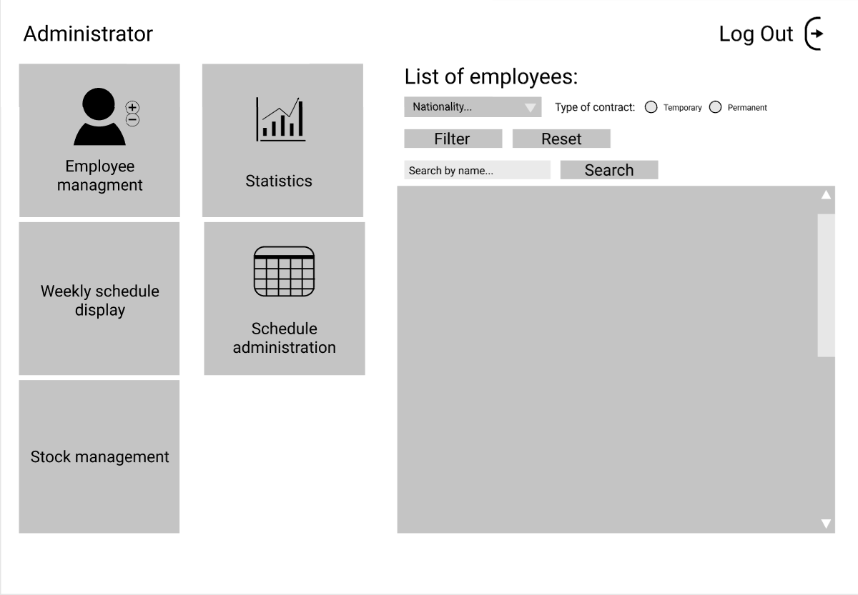

#### Administrator – sub pages

##### Employee management

* + - Administrators can Add, Update (redirects after pressing corresponding button) and Remove employees (by selecting employee in the list and pressing button)

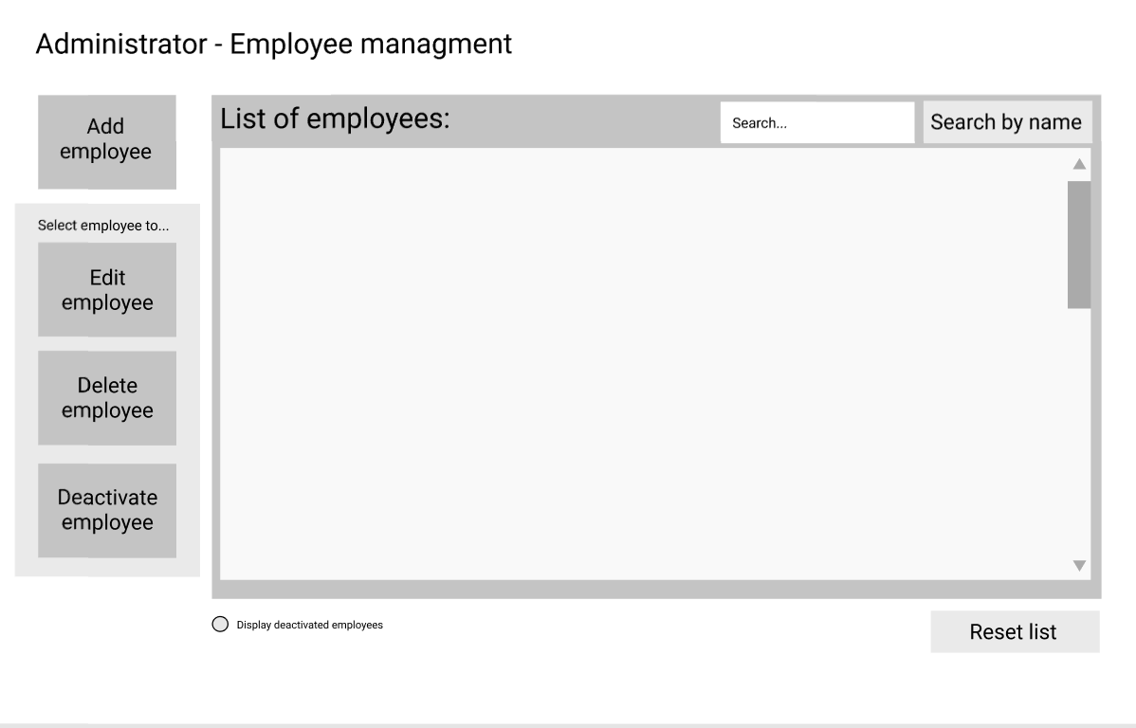

|  |  |
| --- | --- |
|  |  |

##### Administrator – stock management

* Text

  Description automatically generatedChart

  Description automatically generated with medium confidenceAdministrator can add, edit and remove product
* Administrator sees all products on-site and in warehouse

##### Administrator - schedule

* + - Administrators can assign or remove employees from/to shifts
    - With weekly schedule, administrator can see every shift

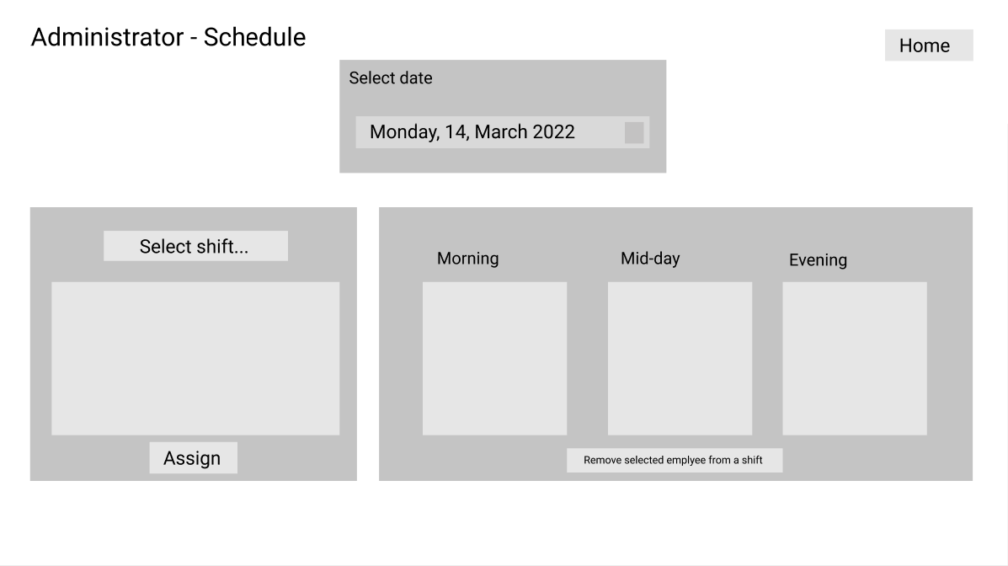

##### Administrator – Statistics

* + - Administrator can see graphs with statistics

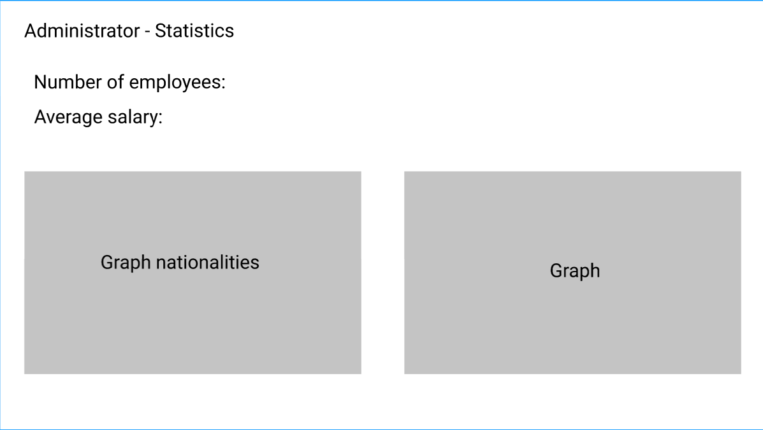

### Manager

#### Manager – main page

* + - 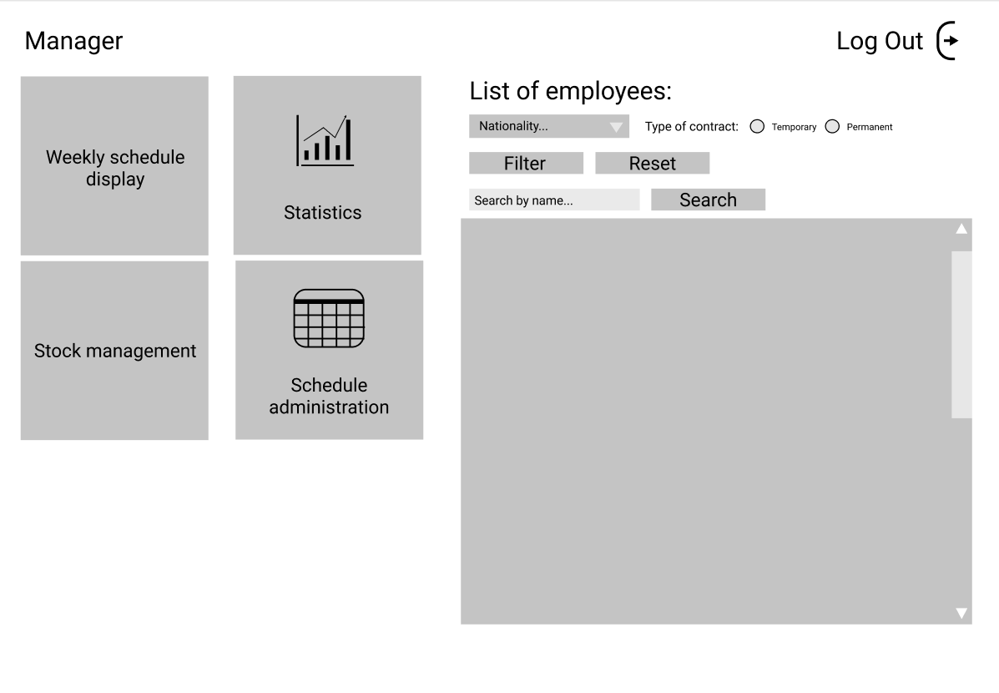The managers’ main page is basically the same as the administrators’, but managers have no access to the Employee management button

#### Manager – Schedule

* + - Managers can only see the schedule, but they can’t edit it

#### Manager – Statistics

* + - Managers can see the same statistics as the administrators



### Worker

#### Worker – Main page

* + - Workers can see their own schedule and re-shelf requests

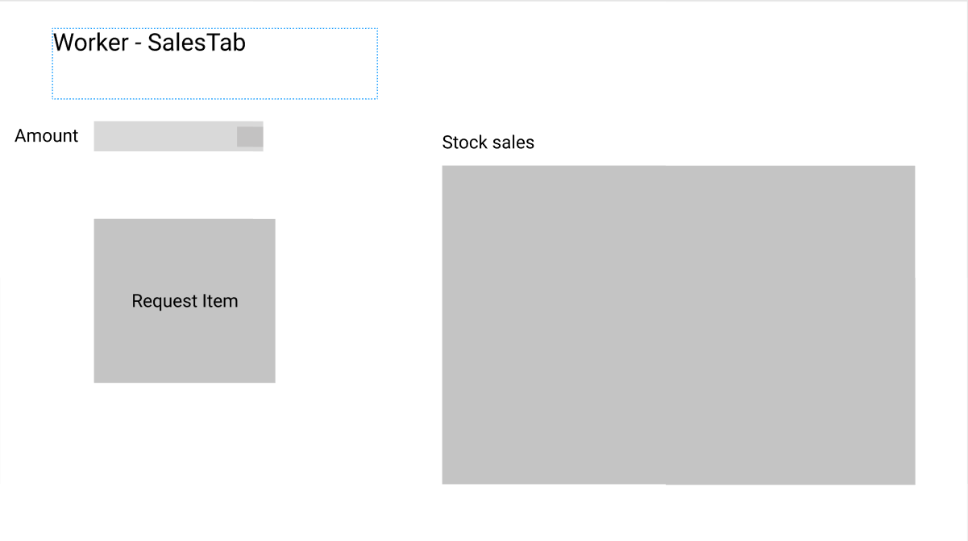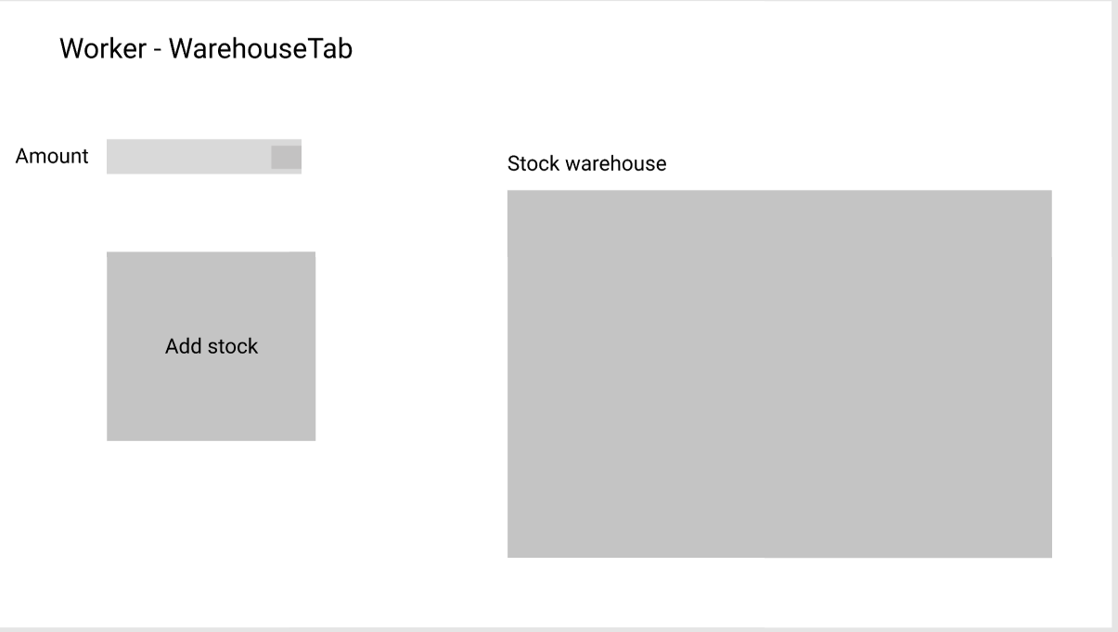

# Website

